

Life Skills LFS102 First Aid

First Aid

Things to remember
- Some knowledge of basic first aid could mean the difference between life and death.
- Consider doing a first aid course, so that you will be able to manage if someone is injured or becomes ill.
- CPR is a life-saving skill that everyone should learn.
- Keep a range of first aid kits handy at home, in the car and at work.
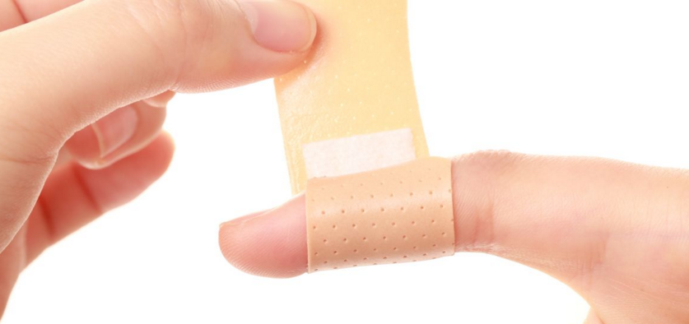

Cut Your Finger?

- Stop Bleeding. Apply direct pressure on the cut or wound with a clean cloth, tissue, or piece of gauze until bleeding stops. ...
- Clean Cut or Wound. Gently clean with soap and warm water. ...
- Protect the Wound. Apply antibiotic cream to reduce risk of infection and cover with a sterile bandage. ...
- Get a small Ice Pack and keep it in the freezer, use over cuts or injuries
- Keep 2 finger plasters in your wallet or purse.

The DRSABCD action plan
If you have completed a first aid course, you will be familiar with the DRSABCD action plan.

Each letter is a prompt for the actions to take when first aid is needed.

DRSABCD ACTION PLAN

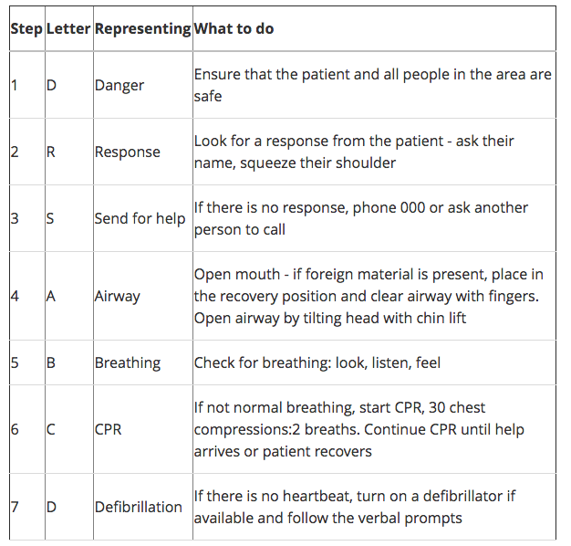

Your basic first aid kit
A basic first aid kit may contain:
- Plasters in a variety of different sizes and shapes
- Small, medium and large sterile gauze dressings
- At least 2 sterile eye dressings
- Triangular bandages
- Crêpe rolled bandages
- Safety pins
- Disposable sterile gloves
- Tweezers
- Scissors
- Alcohol-free cleansing wipes
- Sticky tape
- Thermometer (preferably digital)
- Skin rash cream, such as hydrocortisone or calendula
- Cream or spray to relieve insect bites and stings
- Antiseptic cream
- Painkillers such as paracetamol (or infant paracetamol for children), aspirin (not to be given to children under 16), or ibuprofen
- Cough medicine
- Antihistamine cream or tablets
- Distilled water for cleaning wounds
- Eye wash and eye bath
It may also be useful to keep a basic first aid manual or instruction booklet with your first aid kit.
Medicines should be checked regularly to make sure they're within their use-by dates.
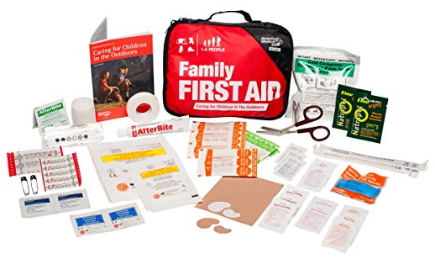

First aid for a medication or drug overdose
Medications are very unpredictable. Many medications or illicit drugs have dangerous side effects, particularly if they are mixed together or taken with alcohol.
If you are aware or suspect that someone you have found has overdosed on drugs or medications, do not leave them to ‘sleep it off’. A doctor or ambulance paramedic should assess any person who overdoses on any medication.
It is very important that you call triple zero (000) if you are aware or suspect that someone you have found has overdosed on drugs or medications, as many overdoses cause death.

Reducing the risk of infected wounds during first aid
Open wounds are prone to infection. Suggestions to reduce the risk of infection include:
- Wash your hands if possible before managing the wound. You could also use an antibacterial hand sanitiser.
- Put on the disposable gloves provided in your first aid kit.
- Try to avoid breathing or coughing over the wound.
- Cleaning of the wound depends on the type and severity of the wound, including the severity of the bleeding. You may just clean around the wound.
- Cover the wound with a sterile dressing. Try not to touch the dressing’s surface before applying it to the wound.
- Seek medical advice or call triple zero (000) for an ambulance.
In an emergency, these suggestions may not be practical. If the injured person is bleeding heavily, don’t waste time. For example, cleaning the wound might dislodge a blood clot and make the wound bleed again or bleed more.
Immediately apply pressure to a heavily bleeding wound (or around the wound if there is an embedded object), and apply a bandage when the bleeding has slowed down or stopped. Call triple zero (000) immediately.

Making an arm sling
After being bandaged, an injured forearm or wrist may require an arm sling to lift the arm and keep it from moving. Steps include:
- Arrange the person’s arm in a ‘V’ so that it is held in front of their body and bent at the elbow, with the hand resting in the hollow where the collarbone meets the shoulder.
- Open a triangular bandage and place it on top of the injured arm. The longest edge needs to be lengthwise along the person’s body and the point of the bandage should be towards the person’s elbow on their injured side. You only need enough material to tie a knot at the fingertip end.
- Create a cradle (hammock) around the injured arm by folding the upper half of the long edge under the injured arm.
- Gently gather the material together at the elbow and pull it tight without pulling the bandage off the injured arm. Twist the material into a long spiral.
- Bring the long spiral around and then up the person’s back.
- Tie the two ends together firmly at the person’s fingertips.

Where to get help
- In an emergency, always call triple zero (000)
- Your doctor
- The emergency department of your nearest hospital
- St John Ambulance Australia (Victoria) for first aid and CPR courses Tel. 1300 360 455
- Australian Red Cross for first aid and CPR courses Tel. 1300 367 428

